Mongo Shell

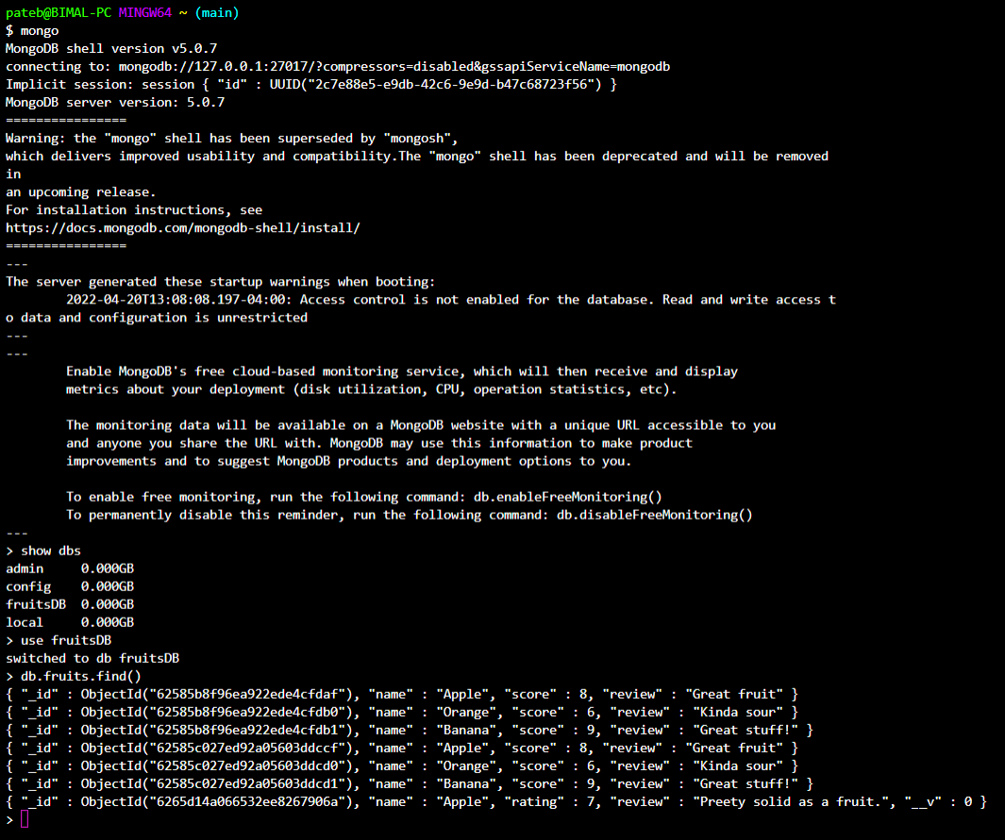

Last insertion is from mongoose rest is through mongo dB.